 |  | University of Central Punjab
 |  | Faculty of Information Technology
 |  | Data Structures and Algorithms
 |  | Spring 2022
 |  | Lab 10
Topic | • | Recursion and BST
 | • | The basic purpose of this lab is to learn and implement BST
Objective


Instructions:

- Indent your code.

- Comment your code.

- Use meaningful variable names.

- Plan your code carefully on a piece of paper before you implement it.

- Name of the program should be same as the task name. i.e. the first program should be Task_1.cpp

- void main() is not allowed. Use int main()

- You have to work in multiple files. i.e separate .h and .cpp files

- You are not allowed to use system("pause")

- You are not allowed to use any built-in functions
- You are required to follow the naming conventions as follow:

- Variables: firstName; (no underscores allowed)

oFunction: getName(); (no underscores allowed)

oClassName: BankAccount (no underscores allowed)

Students are required to complete the following tasks in lab timings.

Lab Task 1
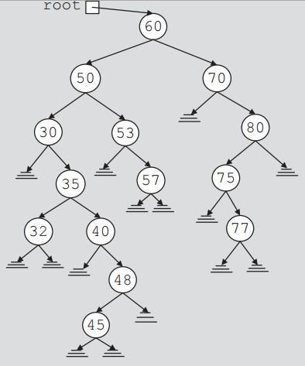

Write the recursive code of searching in a BST. Using your recursive insertion code, create the binary tree (given on the right) and search 75, 40 and 1001 in it print the results.

Lab Task 2

Now write three print functions through recursion which prints the tree in task 1 in following orders:

- Pre-Order

- In-Order

- Post-Order

Lab Task 3

Now write a recursive function which prints the height of the BST and test it on the tree made in task1.

Lab Task 4

Now write a recursive function which counts the leaf nodes of the BST and test it on the tree made in task1.

Lab Task 5

Now write a recursive function which convert a BST into its Mirror Tree, test it on the tree made in task1.

Mirror Tree Example:
